**How to Move TempDB to New Drive in SQL Server**

### Langkah-langkah pindahkan TempDB ke Drive lainnya :

* Identify the location of TempDB Data and Log Files
* Change the location of TempDB Data and Log files using ALTER DATABASE
* Stop and Restart SQL Server Service
* Verify the File Change
* Delete old tempdb.mdf and templog.ldf files

1. Identifikasi lokasi TempDB dan log files dengan query berikut :

Use master

GO

SELECT

name AS [LogicalName]

,physical_name AS [Location]

,state_desc AS [Status]

FROM sys.master_files

WHERE database_id = DB_ID(N'tempdb');

GO

1. Matikan server sql agent

1. Move TempDB to another Drive dengan query berikut :

USE master;

GO

ALTER DATABASE tempdb

MODIFY FILE (NAME = tempdev, FILENAME = 'E:\BTN\DBA\SQL SERVER\Move DB tempDB to another Drive\tempdb.mdf');

GO

ALTER DATABASE tempdb

MODIFY FILE (NAME = templog, FILENAME = 'E:\BTN\DBA\SQL SERVER\Move DB tempDB to another Drive\templog.ldf');

GO

ALTER DATABASE tempdb

MODIFY FILE (NAME = temp2, FILENAME = 'E:\BTN\DBA\SQL SERVER\Move DB tempDB to another Drive\tempdb_mssql_2.ndf');

GO

ALTER DATABASE tempdb

MODIFY FILE (NAME = temp3, FILENAME = 'E:\BTN\DBA\SQL SERVER\Move DB tempDB to another Drive\tempdb_mssql_3.ndf');

GO

ALTER DATABASE tempdb

MODIFY FILE (NAME = temp4, FILENAME = 'E:\BTN\DBA\SQL SERVER\Move DB tempDB to another Drive\tempdb_mssql_4.ndf');

GO

ALTER DATABASE tempdb

MODIFY FILE (NAME = temp5, FILENAME = 'E:\BTN\DBA\SQL SERVER\Move DB tempDB to another Drive\tempdb_mssql_5.ndf');

GO

ALTER DATABASE tempdb

MODIFY FILE (NAME = temp6, FILENAME = 'E:\BTN\DBA\SQL SERVER\Move DB tempDB to another Drive\tempdb_mssql_6.ndf');

GO

ALTER DATABASE tempdb

MODIFY FILE (NAME = temp7, FILENAME = 'E:\BTN\DBA\SQL SERVER\Move DB tempDB to another Drive\tempdb_mssql_7.ndf');

GO

ALTER DATABASE tempdb

MODIFY FILE (NAME = temp8, FILENAME = 'E:\BTN\DBA\SQL SERVER\Move DB tempDB to another Drive\tempdb_mssql_8.ndf');

GO

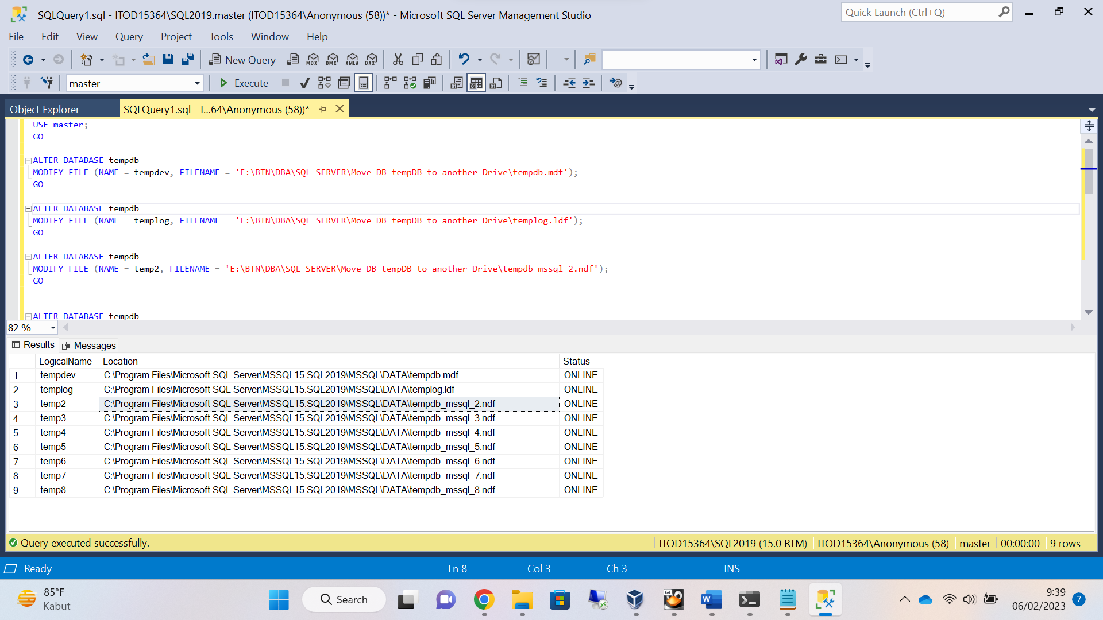

1. Restart instance database (dari ssms atau dari sql configuration)

1. Identifikasi file log setelah dipindahkan ke drive lainnya

Use master

GO

SELECT

name AS [LogicalName]

,physical_name AS [Location]

,state_desc AS [Status]

FROM sys.master_files

WHERE database_id = DB_ID(N'tempdb');

GO

1. Hapus file log, mdf dan ndf yang sebelumnya.
2. Cek folder apakah mdf, ldf dan ndf sudah berada pada drive baru

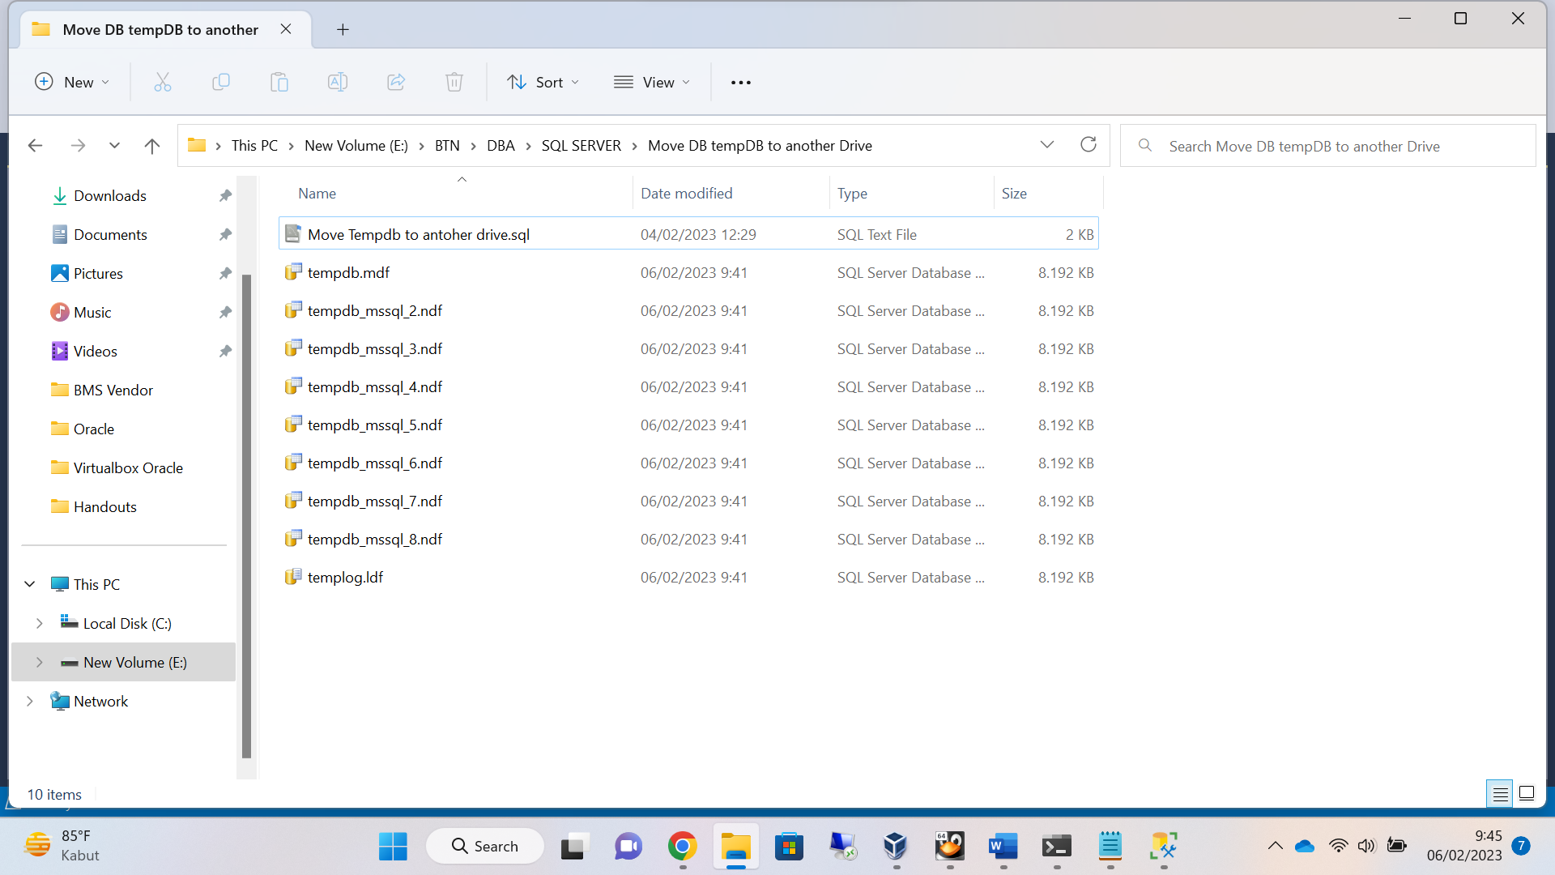

1. Selesai